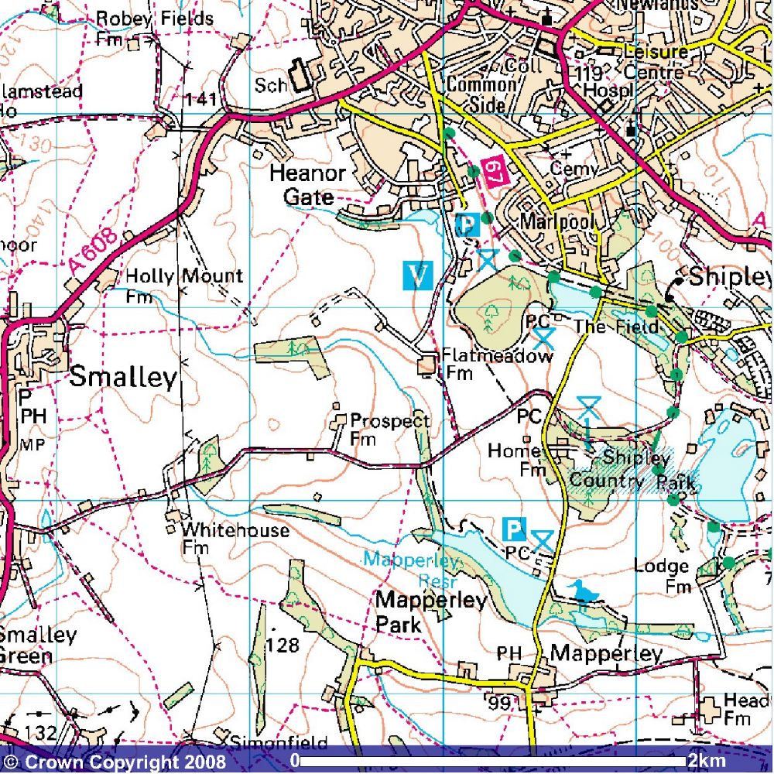
How to find Prospect Farm

Directions:

Bus from Nottingham:
R1 to Heanor from the Victoria Centre
Mondays to Saturdays:
6.30, 7.00, 7.20, 7.30, 7.50, 8.00, 8.15, 8.30, 8.50, then 00, 20, 30, 50, past the hour until 4.00, 4.20, 4.30, 4.50, 5.00, 5.20, 5.30, 5.50, 6.00, 6.20, 6.30, 7.00, 7.30, 8.00, 8.30, 9.00, 9.30, 10.00, 10.30, 11.00, 11.30, 12.00a, 12.30a 1.00a, 1.30a, 2.00a, 2.30a, 3.00a, 3.30a (a= leaves from upper parliament st)

Sundays:
9.00, 9.30, then 00 and 30 past the hour until 11.30

Get off in Heanor then walk south west towards Heanor Gate Industrial Park, and Shipley Coutry Park visitors centre (blue V on map). Follow foot path on map from there.

Bus from Derby to Smalley
H1 Derby City Centre, Corporation St stop J2.
Mondays to Saturdays:
6.50, 7.10, 7.35, 7.55, 8.15, 8.40, 9.00, 9.25, 9.45 then 05, 25, 45 past the hour until 5.05, 5.30, 5.50, 6.15, 6.35, 7.05, 7.35, 8.05, 8.35, 9.05, 9.35, 10.35, 11.35, 12.35, 1.35, 2.35

Sunday:
- then 35 and 05 past the hour until 6.05.

Get off at beginning of Smalley, and walk along Bell Lane, past the Lodge and whitehouse farm to Prospect farm.

Road From the M1
Take the A610 from Junction 26, then the A6008 to Heanor. Then take A60007 to Ilkeston. When have left Heanor and in Shipley, turn right to Shipley Coutry park. Just before Home farm turn right onto Bell Lane. Prospect farm is half way along Bell Lane to Smalley.

